|  |
| --- |
| 0hnQGAuNPo4wojnr77c2x8cWiaT70FGHBZ2h-3__FYQ.png |
| Quicksort |
| Data Structures Made Easy |
|  |

dublin city university

***Contents***

[1. *Definition* 3](#_Toc350375289)

[2. *Implementation* 3](#_Toc350375290)

[3. *Example* 3](#_Toc350375291)

[4. *Functions* 4](#_Toc350375292)

[5. *Pseudocode* 4](#_Toc350375293)

[6. *Complexity* 5](#_Toc350375294)

[7. *Advantages of Quicksort* 5](#_Toc350375295)

[8. *Disadvantages of Quicksort* 5](#_Toc350375296)

[9. *References* 5](#_Toc350375297)

# 1. *Definition*

Quicksort is a sorting algorithm that was created by C. A. R. Hoare. It is a sorting algorithm that operates by recursively partitioning elements, which are to be sorted into two separate sets. Quicksort is based on the ‘divide and conquer’ principal.

# 2. *Implementation*

Quicksort works as follows:

1. Select an element of the array to be the pivot.
2. Divide the remaining elements into two partitions.

* Elements that are less than the pivot are to be placed in the first partition.
* Elements that are greater than the pivot are to be placed in the second partition.

1. Sort both partitions using recursion.
2. Combine the following in order:

* The first (sorted) partition.
* The pivot.
* The second (sorted) partition.

# 3. *Example*

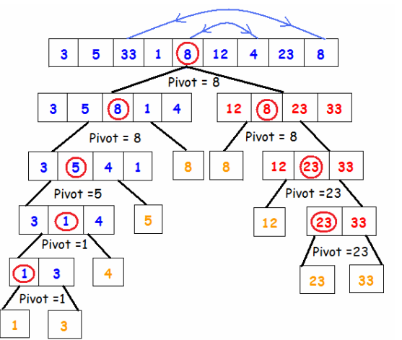

# 4. *Functions*

The implementation of Quicksort is based on the following functions

* **quick ()**

This function selects an element from the array, which is called the pivot. The remaining elements are compared from left to right until a greater element is located and the values are swapped. The same comparison technique is repeated from the right to left with the pivot. When a smaller element is located, the values are swapped.

This process is repeated until all elements that are less than the pivot are positioned before the pivot and all the elements that are greater than the pivot are positioned after the pivot. Partitioning takes place and the function recursively sorts the sub-array’s of lesser and greater elements.

# 5. *Pseudocode*

function quick ( array arr, low, high ){

lo = low

hi = high

if lo is greater than hi

return

pivot = midpoint of arr

while lo is less than hi

while arr[lo] is less than pivot

increment lo

while arr[hi] is greater than pivot

decrement hi

if hi is less than lo

swap ( hi, lo )

quick ( arr, low, lo )

quick ( arr, if lo equals low then increment lo else lo, high )

}

# 6. *Complexity*

The optimal time complexity of Quicksort is O(n). This is achieved by dividing the array into two sets that are nearly identical. If the array contains n elements, then the first process will need O(n). Sorting the remaining sub-arrays will result in the average time complexity of O(n Log n).

The worst case time complexity is O(n^2). This arises if the sorting algorithm selects only one element in each iteration.

# 7. *Advantages of Quicksort*

Quicksort is one of the fastest algorithms to be used and is believed to be the best sorting algorithm. This is due to the fact that it is capable of sorting a large list of items in a satisfactory amount of time.

Quicksort does not require additional memory as it is processes in-place (sorting within the array). Developers regarded this as a huge beneficiary, in terms of memory storage.

# 8. *Disadvantages of Quicksort*

Quicksort’s worst-case performance contributes mainly to its disadvantages. Quicksort’s worst-case performance resembles the average performances of other sorts, such as selection sort, insertion sort and bubble sort.

# 9. *References*

Vogel L. 2012. *Quicksort in Java* [Online]. Available from:

<http://www.vogella.com/articles/JavaAlgorithmsQuicksort/article.html>

Jitomirsky E. 2013. *The Quicksort Algorithm* [Online]. Available from:

<http://www.mycstutorials.com/articles/sorting/quicksort>